Undo and redo
Undo and redo
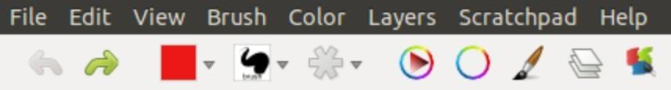

One of the main advantages of any painting or graphics application is the availability of options to
‘Undo’ and ‘Redo’ the previous action on the canvas.

Method 1 - From menu bar
Go to Edit in the menu bar and select Undo Painting or Redo Painting (Edit >Undo/Redo)

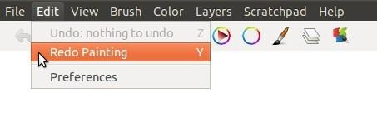
Method 2 - From graphical tool bar

Select the Undo or Redo tools as shown below from the tool bar.

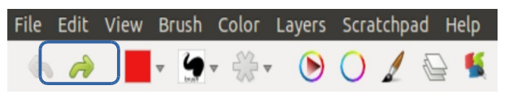

Method 3 - Using Shortcut keys

Undo - Press Z key or ''Ctrl'' and Z key on the keyboard (Ctrl + Z) Redo - Press Y key or ''Ctrl'' and Y key on the keyboard (Ctrl+Y)

