Background Colour

- Go to Layers > Choose Background in the menu bar
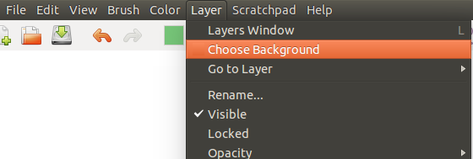

- The background window will appear, showing a collection of different backgrounds. It has two tabs namely pattern and color as shown below:
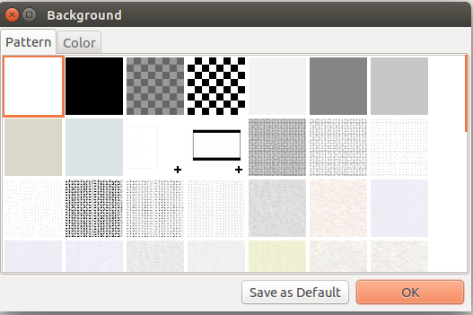
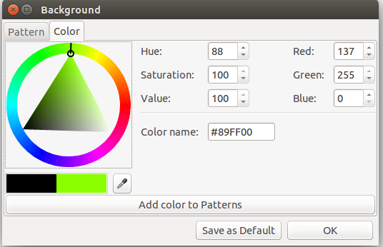

- After selecting the pattern or colour and clicking OK, the background will change to that pattern/colour.

