Saving images in editable format

Editable formats are the ones which can be edited. To save the image in an editable format, select File →Save or press Ctrl+S.
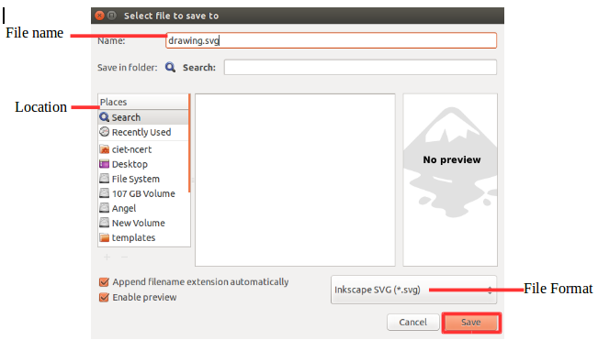
In the window that appears, give the location and appropriate filename and click save. Inkscape uses the SVG (Scalable Vector Graphics) format for its files i.e it is the native file format. SVG is an open standard supported by most browsers (not by IE). SVG files are based on XML and can be edited with any text or XML editor (apart from Inkscape).
File →save us or Shift+Ctrl+S can be used save the file in another name.

