Tweak shapes

Method 1 - Using editing handles:
A newly created shape remains selected and displays its editing handles (square & circular handles). To tweak a shape move your cursor to the editing handle and when you see the colour of the editing handle change from white to red, left click and drag these handles.

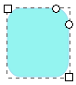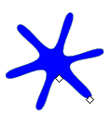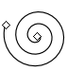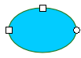

Editing handles of square, star, spiral and ellipse shapes

Method 2 - Controls panel:
Another way to tweak a shape is by using the Controls panel. The controls panel of a shape becomes visible (above the horizontal rulers) after a shape tool has been selected.
The Controls panel of every shape tool has different numeric parameters. After creating a shape, when the numeric parameters are changed, it will affect the currently selected shape (i.e. those that display the editing handles).
Controls bar of different shape tools with different numeric parameters (as shown below) can be used to tweak shapes:
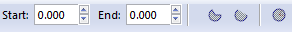Circle/ellipse/arcSpiralRectangle/square
Polygon/star

Undo and Redo
To undo your last action, press Ctrl+Z. To redo the undone action by Shift+Ctrl+Z.
Undo | Ctrl+Z
Redo | Shift+Ctrl+Z

