Selecting an object
The topmost tool (first tool) on the left toolbox that allows you to select objects is called the Selector . You can switch to this tool not only by clicking its button but also by pressing either F1, S or space.
It is a very important tool in inkscape as almost all commands work on the object only if it is selected.
Basic selection: Click on any object, which you would like to select and the object is selected. You can view the status bar message that tells you what exactly has been selected.
Each individual object within a selection displays a selection cue — by default, a dashed rectangular frame (as in Figure below). This dashed frame makes it easy to see at once what is selected and what is not.
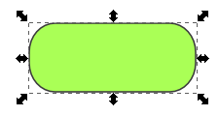
The selected object
Shift+clicking on a selected object exclude it from the selection.
Pressing Esc key deselects any selected objects.
Selection without using the selector tool:
Action | Shortcut keys
To select under | Alt + Click
To add to selection | Shift + click
To exclude a selected object | Shift + click
To select all objects in the current layer | Ctrl + A

Multiple selections
To select more than one object, Press Shift and click the object you want to add to the list of selected objects. Pressing Shift and clicking on any already selected object will deselect it.

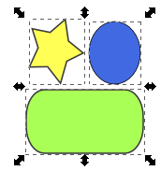

Rubber band selection
But if you would like to select say 20 objects simultaneously, press the mouse button and move the mouse without releasing the button across all the objects you want to select. You will see a rectangular rubber band which follows your mouse. When you release the mouse, all objects that are completely inside the rubber band will get selected:
Ctrl+A selects all objects in the current layer (if you did not create layers, this is the same as all objects in the document).

