Inkscape Interface

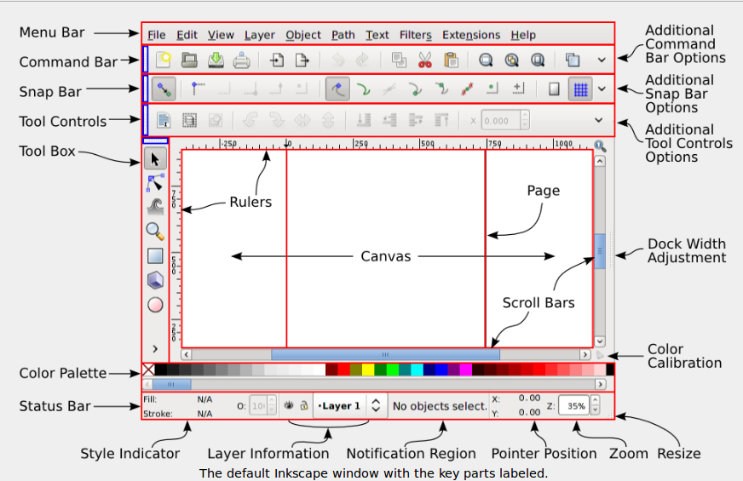
The vertical toolbar on the left shows Inkscape's drawing and editing tools.
In the top part of the window, below the menu, there's the Commands bar with general command buttons and the Tool Controls bar with controls that are specific to each tool. The status bar at the bottom of the window will display useful hints and messages as you work.
Many operations are available through keyboard shortcuts. Open Help > Keys and Mouse to see the complete reference.

