Pencil tool and Calligraphy pen
Writing text using pencil tool
By using a pencil tool you can draw and also input text. Choose the Pencil Tool icon (shown below) from the left pane by clicking on it.
Pencil icon cursor will appear on the canvas. Then by moving the mouse, the required text can be written on the canvas. For example, writing the alphabet ‘C’ using the pencil tool appears as below:
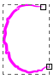
The pencil tip can be smoothen by dragging the slider in smoothing tool seen below the menu bar when pencil tool is selected.
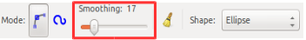
By increasing the value in the smoothing bar, the pencil tip becomes smooth and the image appears to be smooth. For example when after increasing the smoothing values, if the alphabet ‘C’ is written, it appears as below.
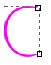
By decreasing the value in the smoothing bar, the pencil tip becomes rough and the image appears is not smooth. For example when after decreasing the smoothing values, if the alphabet ‘C’ is written, it appears as below.
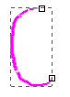
Writing text using Calligraphy tool
Inkscape provides the option of using calligraphy tool .Calligraphy tool enables to write the text in calligraphic form or to raw images. To use the calligraphy tool, click on calligraphy tool icon (shown in figure below) or press Ctrl+F6 or C.
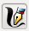
When calligraphy tool is selected mouse cursor will change into calligraphy pen cursor .Using the mouse you can write on the canvas
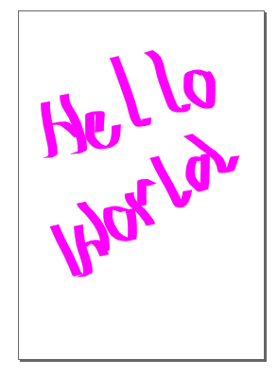
Left / Right keys of the keyboard can be used to adjust the stroke width and Up/ Down keys can be use to adjust the angle .This can also be done by increasing and decreasing the values in calligraphy toolbar.
