Adding Text using text tool

Text can be added in multiple ways say using text tool or by writing using a pencil or calligraphy tool.

To add text using text tool
- click on the “text object” icon (like an “A”) on the left hand menu as shown in the below screenshot. Shortcut for selecting the text icon is Shift+Ctrl+T. click using your mouse where you want to add text in the screen. Mouse arrow appears on the screen

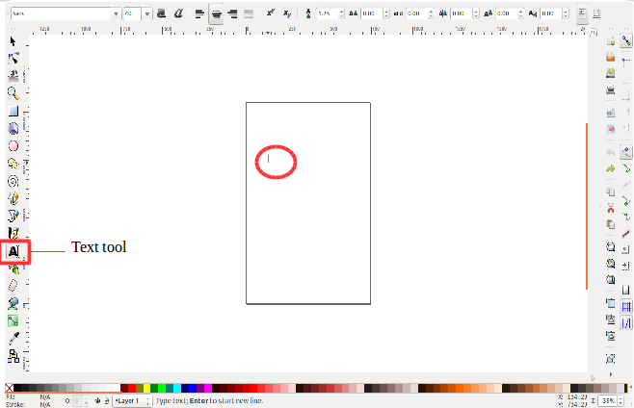
- Then simply add text with typing using your keyboard. The types text appears on the screen.
To select text click left button on mouse and drag it. If you want to select all the text, then press just Ctrl+A. All the text in the screen gets selected as shown below:

