Text Features

In word processor, you can change the format of the text in terms of its type, colour, style (boldface, italic) and size. To do this select Format>Character.

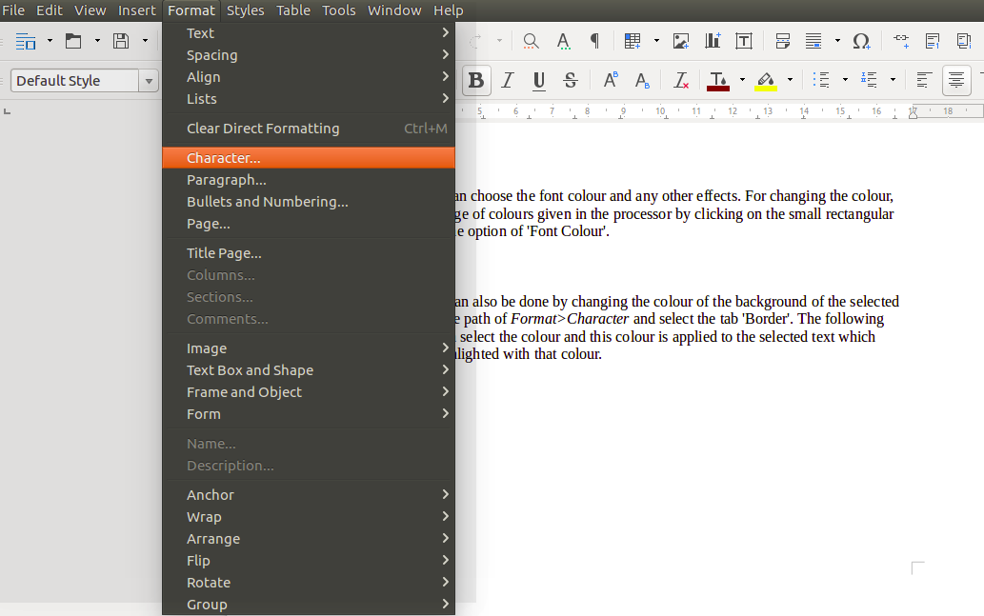

This displays a dialogue box which has various tabs like 'Font', 'Font Effects', 'Position', 'Hyperlink' and 'Background.'

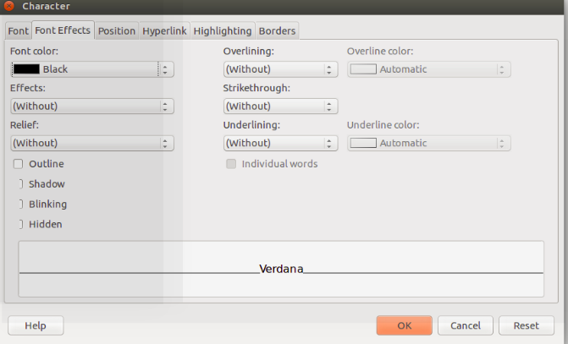

Font type, size and style

You can select the tab 'Font' in the window to change the styling of the text by choosing a different 'Family', 'Style' and 'Size'. When you choose a font from this window, the style of the text or how the text will appear is displayed in the rectangular box given at the bottom of the window. Click on 'OK' to complete the process.
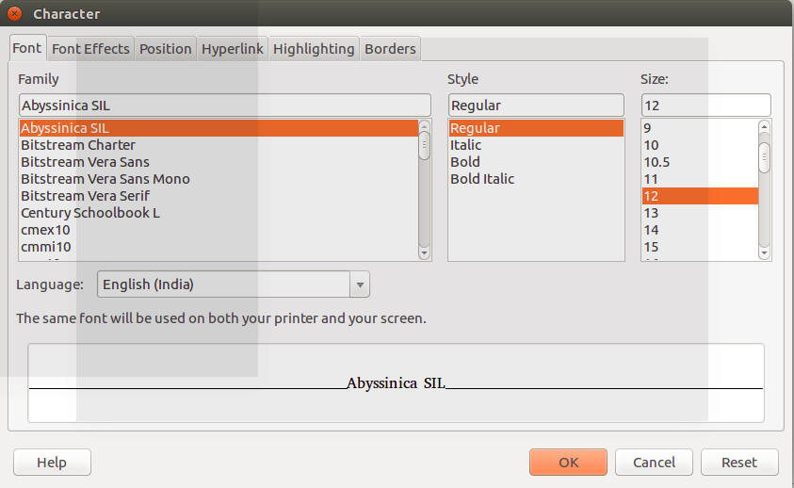

Font colour
To change the colour of the text, select the text first.

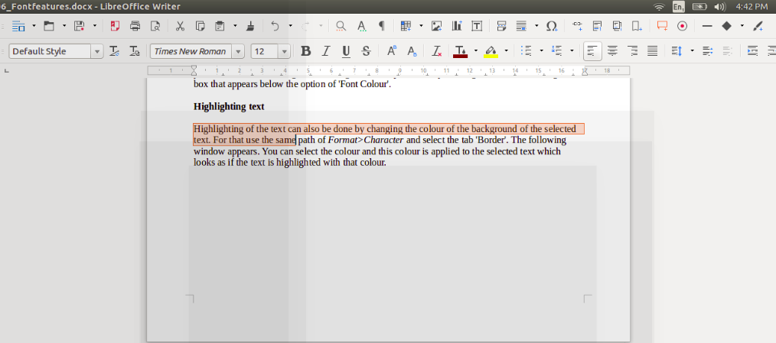

Then go to Format>Character and the same window that opened for changing the font will appear. Now, you have to select the tab 'Font Effects' given in the window.

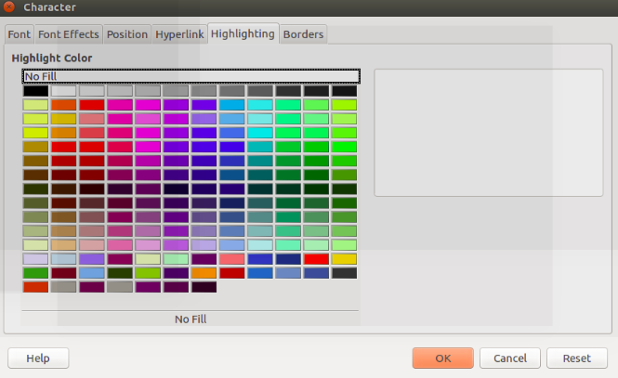

From this window, you can choose the font colour and any other effects. For changing the colour, you can select from a range of colours given in the processor by clicking on the small rectangular box that appears below the option of 'Font Colour'.
Highlighting text

Highlighting of the text can also be done by changing the colour of the background of the selected text. For that use the same path of Format>Character and select the tab 'Border'. The following window appears. You can select the colour and this colour is applied to the selected text which looks as if the text is highlighted with that colour.

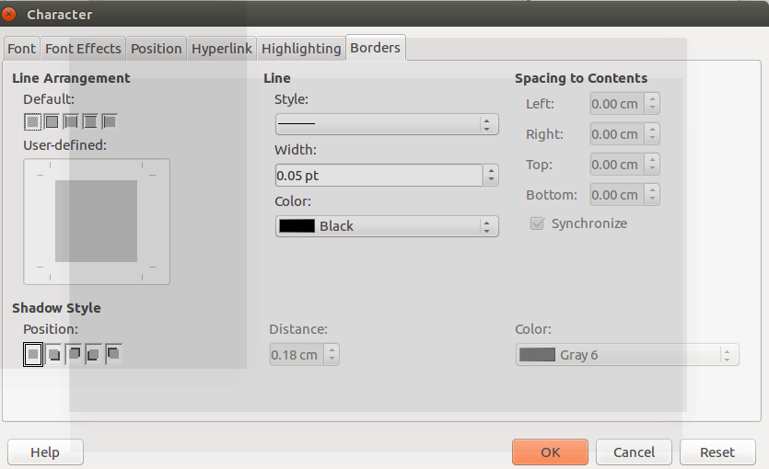

Font type, size, style, colour and highlighting can also be done by selecting the appropriate icon available in the tool bar.

