Introduction to Openshot Editor

Openshot video editor helps in video editing as well to collate images, audio, video etc into a digital output. To open open shot shot video editor search for the icon in the desktop or search in the search bar. Once you open a openshot editor, the interface of the editor will appear as shown below which has all the tools, informations and buttons required to edit the videos.

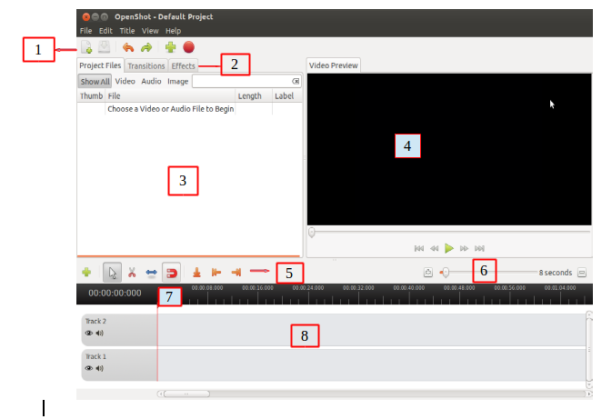

1- is Main toolbar of openshot editor it contains buttons to open , save and export video project.

2- is Function tab , this tab let you switch between 3 different functions: Project Files, Transitions, and Effects. The items in these tabs can be dragged and dropped onto the timeline.

3- The Project Files section contains all files that have been imported into your project. Before you can add an image, audio file, or video file to your project timeline, it must first be imported into your Project Files section

4- is Preview window where video will playback on the screen.The Preview Window is what controls the playback (or preview) of your video project. Clicking the buttons under the preview window controls the playback, and outputs video to this area.

5- is Edit Toolbar which contains toggle buttons used for editing, trimming, and splitting clips.

6- The zoom slider allows you to change the time-scale of the timeline. Zoom in to see the timeline more closely, or zoom out the see the entire project without scrolling. You can either click the zoom buttons (on the left and right), or slide the zoom slider. When dragging the slider, it will update the timeline when you pause or stop moving it.

7- is Play head/ Ruler where the ruler shows the time-scale, and the red line is the play-head. The play-head represents the current playback position.

8-is the Timeline which visualizes your video project, and each clip and transition in your project.

9- is the FILTER , it Filter the list of items shown (project files, transitions, and effects) by using buttons and textbox.Enter a few letters of what you are looking for, and the results will be shown.

