READING A DATA THROUGH GRAPHS/CHARTS
Following snapshot depicts the Column chart based of data used in handout 1 . It depicts percentage of each students:
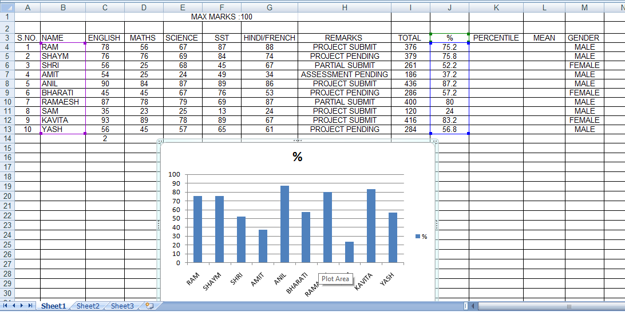
This chart will help the student to read the data quickly .
For example :
1.It depicts the high scorer of the class very clearly
2. It is showing the lowest scorer of the class also
3. Chart or Graph Enable Student Subject Wise Marks comparison
4. Suggestive recommendations for low Or High Achievers can be done from Chart.

