Mixing colour changing the hue its saturation level and brightness level

New colours can be made, by changing the hue its saturation and brightness level. Hue, saturation, and brightness are aspects of colour in the red, green, and blue (RGB) scheme. These terms are most often used in reference to the colour of each pixel in a cathode ray tube (CRT) display. All possible colours can be specified according to hue, saturation, and brightness (also called brilliance), just as colours can be represented in terms of the R, G, and B components. Saturation is an expression for the relative bandwidth of the visible output from a light source. Brightness is a relative expression of the intensity of the energy output of a visible light source.
- Click on the colour palette icon highlighted in image below.

- In the Tab that opens up, you can see the hcy wheel as shown below. It consists of colour circle and brightness level
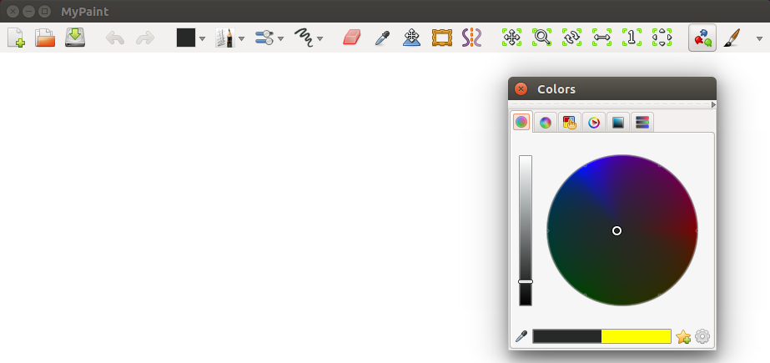
- Brightness level refers to how much white (or black) is mixed in the colour while Saturation indicates the amount of grey in a colour. If you move up Brightness level it will give you lightness to the colour. And if you move brightness slider to down, then it will colour shades to dark.
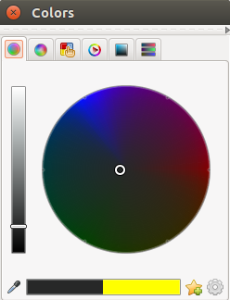
- Now in the hcy wheel you can choose the colour by clicking on any shades of colour within the circle.

Thus, by using both the brightness slider and hcy wheel, you can mix the colour to your requirement.

