Adding heading to a shape in TurtleArt

1. For adding heading to a shape in TurtleArt, go to 'Palette of turtle commands' in the toolbar
of the application and select the 'show' block from it. The 'show' block allows to add text to
a shape.

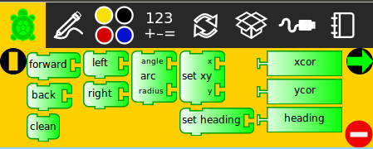

2. When you click on 'show', the 'text' block appears with it by default. Text can be added in this block. See below.

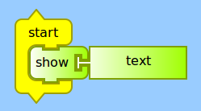

3. After adding the text, click on 'start' block. When the Turtle moves, it adds heading to the
shape it has been commanded to create.
